**University Department Info Page**

**Submitted by:**

**Member 1**

**Name** : S Mehanath

**Reg no** : 2460645

**Mail Id** [:smehanath@btech.christuniversity.in](mailto:Id-smehanath@btech.christuniversity.in)

**Member 2**

**Name** : Tom Boby Alex

**Reg no** : 2462162

**Mail Id :** [tom.boby@btech.christuniversity.in](mailto:tom.boby@btech.christuniversity.in)

**Member 3**

**Name** : Nanda Krishnan

**Reg no** : 2462116

**Mail Id** : [nanda.krishnan@btech.christuniversity.in](mailto:%20nanda.krishnan@btech.christuniversity.in)

**Course** : UI/UX Design Fundementals

**Instructor name**: Narendra

**Institution Name**: Christ University Kengeri Campus

**Date of Submission**:11/08/2025

**2.Abstract**

This project focuses on designing and developing a responsive **University Department Information Page** using only HTML5 and CSS3. The aim is to create a clean, accessible, and informative webpage that provides users with essential details about various academic departments. Key sections include department overviews, faculty profiles, announcements, and a contact form layout. The design follows a mobile-first approach to ensure compatibility across all devices, including desktops, tablets, and smartphones.

By using semantic HTML tags and structured CSS, the layout emphasizes clarity, responsiveness, and user-friendly navigation. Techniques such as Flexbox and Grid are used for layout structuring, while media queries ensure adaptability across screen sizes. No JavaScript or backend integration was included, keeping the project focused entirely on front-end development fundamentals.

The final output is a professional, visually consistent webpage that improves user access to university department information. This project also enhanced our understanding of responsive design and web accessibility best practices.

**3. Objectives**

* Design a clear and informative UI for a university department info page.
* Develop a fully responsive layout using only HTML5 and CSS3.
* Apply modern UI principles for improved user navigation and readability.
* Ensure accessibility and compatibility across all device sizes.

**4. Scope of the Project**

* Focused on front-end design only
* No JavaScript or backend integration
* Designed for mobile, tablet, and desktop viewports
* Used only open-source tools and no frameworks/libraries

**5. Tools & Technologies Used**

|  |  |
| --- | --- |
| **Tools/Technology** | **Purpose** |
| HTML | Structure and form Markup |
| CSS | Styling and Layout |
| VS Code | Code Editor |
| Chrome Dev tools | Testing and Responsive Design |

**6. HTML Structure Overview**

* Used semantic tags: <header>, <nav>, <main>, <section>, <footer>
* Structured into sections: Home, Departments, Faculty, Contact, Announcements
* Navigation menu using <ul> with anchor links for smooth scrolling

**7. CSS Styling Strategy**

* External CSS file: style.css
* Comments and sections for readability
* Techniques:
  + **Flexbox and Grid** for responsive layouts
  + **Media Queries** for screen adaptability
  + **Hover effects and transitions** for interactivity
  + **Mobile-first design** approach

**8. Key Features**

|  |  |
| --- | --- |
| **Feature** | **Description** |
| Responsive Layout | Designed to work well across different screen sizes using CSS media queries. |
| Faculty Accordion | Clickable section to expand/collapse detailed faculty profiles using checkboxes. |
| Course Comparison Panel | Allows users to select and compare course details interactively. |
| Department Course Table | Well-structured table listing courses, codes, and credits. |
| Research Area Icons | Visually engaging icon grid representing key research domains. |
| Semantic HTML Structure | Used semantic tags (<header>, <section>, <footer>) for clarity and accessibility. |
| Clean Typography & Spacing | Readable fonts, clear headings, and spaced sections for better UX |
| Image Integration | Department image aligned centrally to enhance visual appeal. |

**9. Challenges Faced & Solutions**

|  |  |
| --- | --- |
| **Challenge** | **Solution** |
| Accordion logic without JavaScript | Used HTML checkboxes + labels to simulate toggle effect for faculty section |
| Aligning and styling comparison panel content | Used Flexbox/Grid for uniform layout of course cards inside .compare-grid. |
| Image not loading correctly from local path | Realized absolute file paths (like C:\Users\...) won’t work on browsers—used relative path or hosted image instead. |
| Maintaining layout consistency across sections | Applied consistent CSS classes and spacing patterns (padding, margin). |
| Ensuring semantic structure | Used meaningful sectioning tags for better HTML5 practice and accessibility. |
| Responsive behavior for tables and grids | Applied media queries and ensured elements stacked properly on small screens. |

**10. Outcome**

The **University Department Info Page** project successfully achieved its goal of presenting academic department information through a clean, structured, and user-friendly interface. Using only HTML5 and CSS3, the project showcases faculty profiles, course listings, research areas, and comparison features with a responsive and modern design.

Key outcomes include:

* Implemented an interactive **faculty accordion** layout without using JavaScript.
* Built a functional **course catalog** table with a visual **comparison panel**.
* Created a responsive and accessible UI that works across devices.
* Improved skills in semantic HTML structure and CSS layout techniques (Flexbox/Grid).
* Delivered a visually appealing, professional webpage that meets front-end best practices.

**11. Future Enhancements**

To make the department info page more dynamic and functional, the following improvements can be considered:

* 🔧 **Add JavaScript Functionality:** Use JavaScript to create real-time interactivity (e.g., smooth accordion transitions, dynamic search/filter for faculty/courses).
* 🌐 **Backend Integration:** Connect the contact form to a backend service (e.g., PHP, Node.js) for submissions.
* 📱 **Improve Accessibility:** Add ARIA attributes and keyboard navigation support for better usability.
* 🎨 **Dark Mode Toggle:** Allow users to switch between light and dark themes.
* 📊 **Dynamic Course Data:** Load course information from an external JSON file or API instead of hardcoding.
* 👥 **Faculty Profiles Page:** Link each faculty member to a dedicated page with detailed publications, projects, and achievements.
* 📅 **Events or Announcements Section:** Display dynamic updates about departmental activities.
* 🔍 **Search and Filter:** Add filters for departments, faculty specialization, or credit range.

**Sample** **Program**

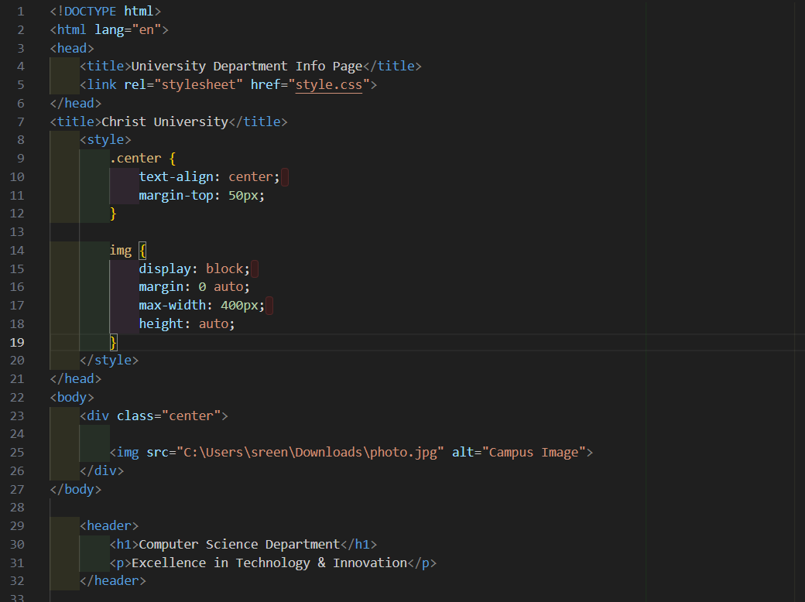

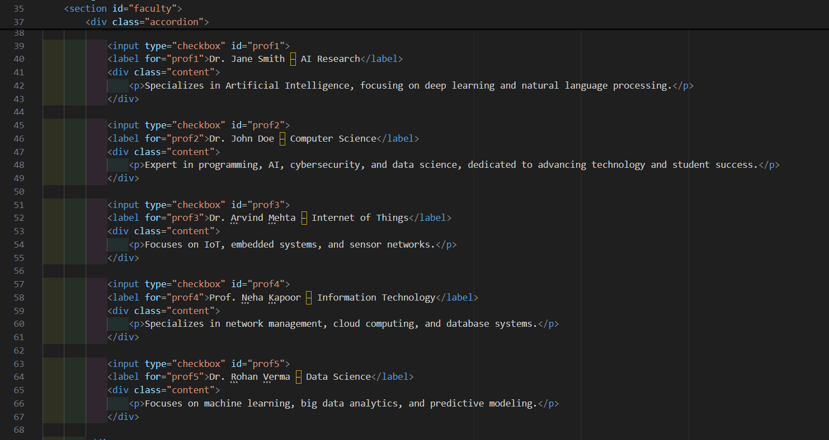

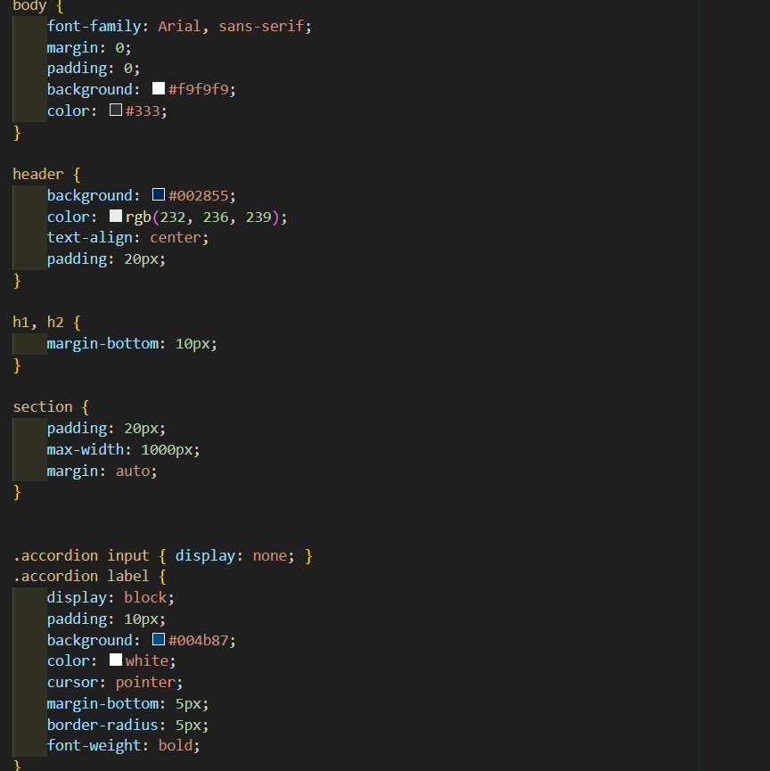

**Screenshot of final output**

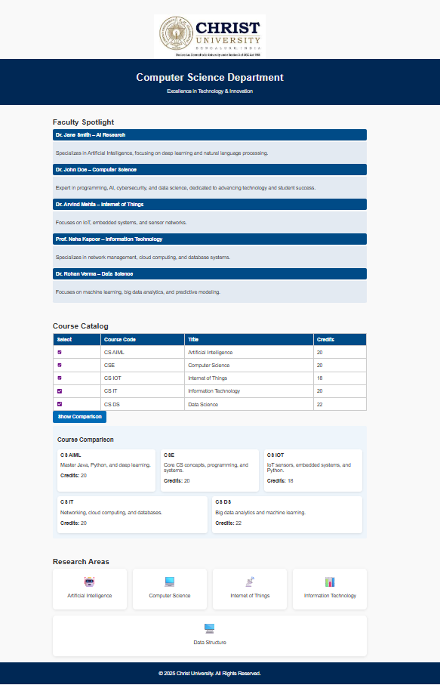

**Conclusion**

The University Department Information System webpage successfully provides a structured, user-friendly, and responsive platform to present detailed information about various departments within the university. By integrating sections such as department overviews, faculty profiles, announcements, and contact details, the system ensures quick access to relevant academic and administrative data. Designed with HTML5 and CSS3, the interface is modern, mobile-compatible, and easy to navigate, meeting the needs of both students and faculty. Overall, this webpage enhances communication, improves accessibility to information, and supports the university’s commitment to a digital-first approach.

**Reference**

L&T LMS : https://learn.lntedutech.com/Landing/MyCourse